FLOOD MONITORNING AND EARLY WARNING
PROGRAM(python):

ine BLYNK_TEMPLATE_NAME "IOT FLOOD MONITORING"
#define BLYNK_AUTH_TOKEN "gy2bzR-i-RbPW3oWOpAiDgr6sSVzIHVZ"
#define BLYNK_TEMPLATE_ID "TMPL3tobBFjj-"
#def
char auth[] = BLYNK_AUTH_TOKEN;
char ssid[] = "Wokwi-GUEST";
char pass[] = "";

#define BLYNK_PRINT Serial
#include <WiFi.h>
#include <WiFiClient.h>
#include <BlynkSimpleEsp32.h>
#include <ESP32Servo.h>
Servo gate;
const int trigPin=2;//d2
const int echoPin=4;//d4
const int servoPin = 18;//d18
long duration;
int distance;

void setup() {
Serial.begin(9600);
Blynk.begin(auth, ssid, pass);
pinMode(trigPin, OUTPUT);
pinMode(echoPin, INPUT);
gate.attach(servoPin, 500, 2400);
}

Libraries.txt

#Wokwi Library List
# See https://docs.wokwi.com/guides/libraries
Blynk
DHT12 sensor library
DHT sensor library
Serve
ESP32Servo
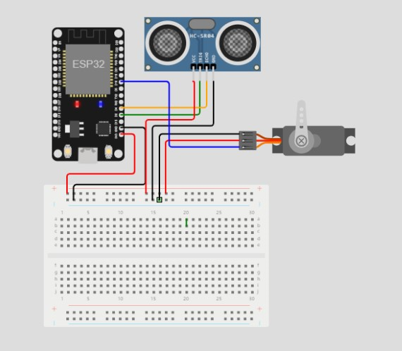

OUTPUT:

